1D Array

1D Array Syntax
In C, a 1D array is a collection of elements of the same type. The syntax to declare a 1D array is:
Declaration of 1D Array:
data_type array_name[array_size];

- data_type: The type of data (e.g., int, float, char).
- array_name: The name of the array.
- array_size: The number of elements in the array.
1.Initialization of 1D Array :
data_type array_name[array_size] = {value1, value2, ..., valueN};
Eg.
//Partial Initialisation (remaining value are zero)
int arr[5] = {2, 4, 8};

//Skiping the size of the array.
int arr[] = {2, 4, 8, 12, 16};

//initialize an array with all elements set to 0.
int arr[5] = {0};

General Example:

#include <stdio.h>
int main() {
// Initialize an array with values directly
int numbers[5] = {10, 20, 30, 40, 50};

// Printing the values
printf("Array elements are:\n");
for (int i = 0; i < 5; i++) {
printf("numbers[%d] = %d\n", i, numbers[i]);
}
return 0;
}

Key Points
- Declaration and Initialization:
  - The array numbers is declared with a size of 5 and initialized with specific values (10, 20, 30, 40, 50) at the same time.
- Accessing Elements:
  - You can access and print the elements using a loop, just like in any other array.
- Partial Initialization:
If you initialize fewer elements than the declared size, the remaining elements are set to zero by default:
int arr[5] = {1, 2}; // arr[2], arr[3], and arr[4] will be 0

- Omitting Size:
  - You can also omit the size during initialization, and the compiler will determine the size based on the number of initializers:
int arr[] = {1, 2, 3, 4}; // Size will be 4
size of array:
#include <stdio.h>
int main() {
int arr[5] = {2, 4, 8, 12, 16};
// Size of the array
int size = sizeof(arr)/sizeof(arr[0]);
printf("%d", size);
return 0;
}

2.1D Array Dynamic Initialization:
int numbers[10];
printf("Enter %d integers:\n", size);
for (int i = 0; i < 10; i++) {
printf("numbers[%d]: ", i);
scanf("%d", &numbers[i]); // Store user input in the array
}

Example of Array Initialization Using a For Loop
#include <stdio.h>
int main() {
int size;
// Asking the user for the size of the array
printf("Enter the number of elements: ");
scanf("%d", &size);
// Declare an array of the specified size
int numbers[size]; // Note: Variable-length arrays are supported in C99 and later
// Taking input from the user to initialize the array
printf("Enter %d integers:\n", size);
for (int i = 0; i < size; i++) {
printf("numbers[%d]: ", i);
scanf("%d", &numbers[i]); // Store user input in the array
}
// Printing the values
printf("You entered:\n");
for (int i = 0; i < size; i++) {
printf("numbers[%d] = %d\n", i, numbers[i]);
}
return 0;
}
Practice Question 👍
- WAP To Print Sum of Array.
- WAP To Print Reverse of A Given Array.
- Find Maximum value in an array
- Finding the Common elements in two arrays
- Find unique elements in an array
- Merging two sorted arrays into one using function
- Searching for an item using binary search.
- Find the difference between two sets or array

1. WAP To Print Sum of Array.

#include <stdio.h>
int main() {
int n;
// Input the number of elements
printf("Enter number of elements: ");
scanf("%d", &n);
int numbers[n];
int sum = 0; // Variable to store the sum
// Taking input from the user
printf("Enter %d integers:\n", n);
for (int i = 0; i < n; i++) {
scanf("%d", &numbers[i]);
sum += numbers[i]; // Add each element to sum
}
// Printing the sum
printf("The sum of the elements is: %d\n", sum);
return 0;
}
2. WAP To Print Reverse of A Given Array.
#include <stdio.h>
int main() {
int n;
// Input the number of elements
printf("Enter number of elements: ");
scanf("%d", &n);
int numbers[n];
// Taking input from the user
printf("Enter %d integers:\n", n);
for (int i = 0; i < n; i++) {
scanf("%d", &numbers[i]);
}
// Printing the elements in reverse order
printf("The reversed array is: ");
for (int i = n - 1; i >= 0; i--) {
printf("%d ", numbers[i]);
}
printf("\n");
return 0;
}
- Finding the Common elements in two arrays
Solution:
#include <stdio.h>

int main() {
int arr1[] = {1, 2, 3, 4, 5};
int arr2[] = {4, 5, 6, 7, 8};
int size1 = sizeof(arr1) / sizeof(arr1[0]);
int size2 = sizeof(arr2) / sizeof(arr2[0]);

printf("Common elements: ");

// Nested loop to find common elements
for (int i = 0; i < size1; i++) {
for (int j = 0; j < size2; j++) {
if (arr1[i] == arr2[j]) {
printf("%d ", arr1[i]);
break; // Break to avoid printing duplicates from arr1
}
}
}

printf("\n");
return 0;
}
- Find unique elements in an array
Solution:
#include <stdio.h>

int main() {
int arr[] = {1, 2, 2, 3, 4, 4, 5, 6, 6, 7};
int size = sizeof(arr) / sizeof(arr[0]);
int unique[size];
int uniqueCount = 0;

for (int i = 0; i < size; i++) {
int isUnique = 1;

for (int j = 0; j < i; j++) {
if (arr[i] == arr[j]) {
isUnique = 0; // Found a duplicate
break;
}
}

if (isUnique) {
for (int k = i + 1; k < size; k++) {
if (arr[i] == arr[k]) {
isUnique = 0; // Found a duplicate
break;
}
}
}

if (isUnique) {
unique[uniqueCount++] = arr[i];
}
}

printf("Unique elements: ");
for (int i = 0; i < uniqueCount; i++) {
printf("%d ", unique[i]);
}
printf("\n");

return 0;
}

2D Array

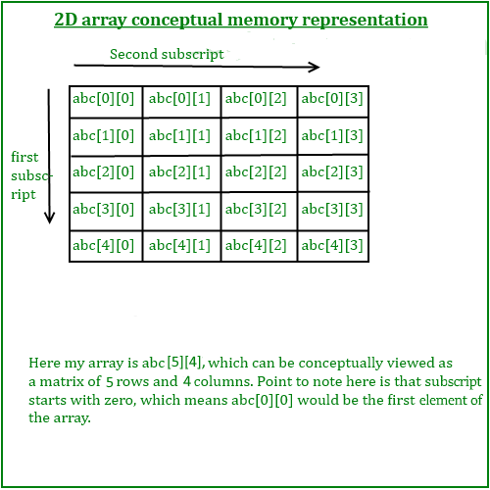

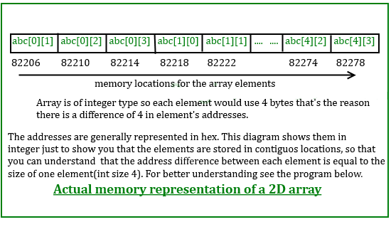

Syntax for Declaration and Initialization
data_type array_name[row_size][column_size] = {
{value1, value2, ..., valueN},
{value1, value2, ..., valueN},
...
};

Example of Declaration and Initialization
#include <stdio.h>
int main() {
// Declare and initialize a 2D array of integers
int matrix[3][4] = {
{1, 2, 3, 4}, // First row
{5, 6, 7, 8}, // Second row
{9, 10, 11, 12} // Third row
};
// Print the 2D array
printf("The 2D array is:\n");
for (int i = 0; i < 3; i++) {
for (int j = 0; j < 4; j++) {
printf("%d ", matrix[i][j]);
}
printf("\n"); // New line after each row
}
return 0;
}

Important Points
- Partial Initialization: You can also partially initialize a 2D array:
int matrix[3][4] = {
{1, 2}, // The rest will be initialized to 0
{5, 6}, // // The rest will be initialized to 0
{9} // The rest will also be initialized to 0
};
In this case, unspecified elements will be initialized to zero.

- Size Determination: If you omit the size for one dimension during initialization, the compiler will automatically determine the size based on the
int matrix[][4] = {
{1, 2, 3, 4},
{5, 6, 7, 8}
};

Here, the number of rows is determined to be 2.

Dynamic Initialization of 2D Array:
#include <stdio.h>
int main() {
// Declare the number of rows and columns
int rows = 3; // Example size
int cols = 4; // Example size

// Declare a 2D array
int matrix[3][4];

// Input values into the 2D array
printf("Enter elements of the matrix (%d rows and %d columns):\n", rows, cols);
for (int i = 0; i < rows; i++) {
for (int j = 0; j < cols; j++) {
printf("Element [%d][%d]: ", i, j);
scanf("%d", &matrix[i][j]); // Store user input in the array
}
}

// Print the 2D array
printf("The 2D array is:\n");
for (int i = 0; i < rows; i++) {
for (int j = 0; j < cols; j++) {
printf("%d ", matrix[i][j]);
}
printf("\n"); // New line after each row
}

return 0;
}

- Find transpose of a given matrix

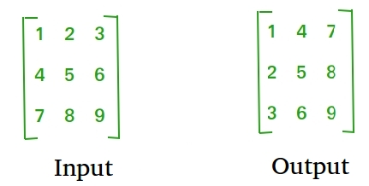

Solution:
#include <stdio.h>
#define MAX_ROWS 3
#define MAX_COLS 3
int main()
{
int A[MAX_ROWS][MAX_COLS]; // Original matrix
int B[MAX_COLS][MAX_ROWS]; // Transpose matrix

int row, col;
printf("Enter elements in matrix of size %dx%d: \n", MAX_ROWS, MAX_COLS);
for(row=0; row<MAX_ROWS; row++)
{
for(col=0; col<MAX_COLS; col++)
{
scanf("%d", &A[row][col]);
}
}

/*
* Find transpose of matrix A
*/
for(row=0; row<MAX_ROWS; row++)
{
for(col=0; col<MAX_COLS; col++)
{
/* Store each row of matrix A to each column of matrix B */
B[col][row] = A[row][col];
}
}

/* Print the original matrix A */
printf("\nOriginal matrix: \n");
for(row=0; row<MAX_ROWS; row++)
{
for(col=0; col<MAX_COLS; col++)
{
printf("%d ", A[row][col]);
}

printf("\n");
}

/* Print the transpose of matrix A */
printf("Transpose of matrix A: \n");
for(row=0; row<MAX_COLS; row++)
{
for(col=0; col<MAX_ROWS; col++)
{
printf("%d ", B[row][col]);
}

printf("\n");
}
return 0;
}

- Sparse Matrix
A sparse matrix is a matrix with a large number of zero elements, or where most of the elements are zero.
T>=(M*N/2)
Where
T:Total No of Zeros
M: No of Rows
N: No of Columns
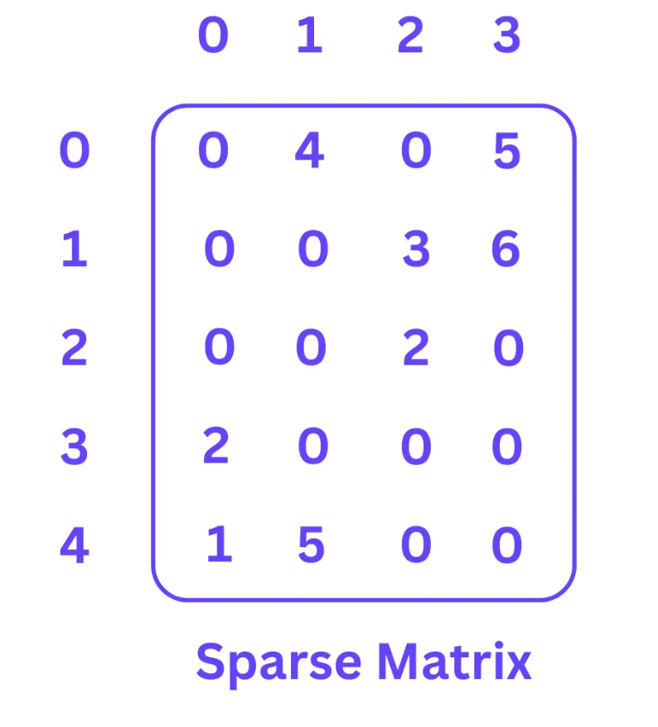

Solution:
#include <stdio.h>
#define SIZE 3

int main()
{
int A[SIZE][SIZE];
int row, col, total=0;

/* Input elements in matrix from user */
printf("Enter elements in matrix of size 3x3: \n");
for(row=0; row<SIZE; row++)
{
for(col=0; col<SIZE; col++)
{
scanf("%d", &A[row][col]);
}
}

/* Count total number of zero elements in the matrix */
for(row=0; row<SIZE; row++)
{
for(col=0; col<SIZE; col++)
{
/* If the current element is zero */
if(A[row][col] == 0)
{
total++;
}
}
}

if(total >= (row * col)/2)
{
printf("\nThe given matrix is a Sparse matrix.");
}
else
{
printf("\nThe given matrix is not Sparse matrix.");
}

return 0;
}

- Multiplying 2 Matrices :

Example
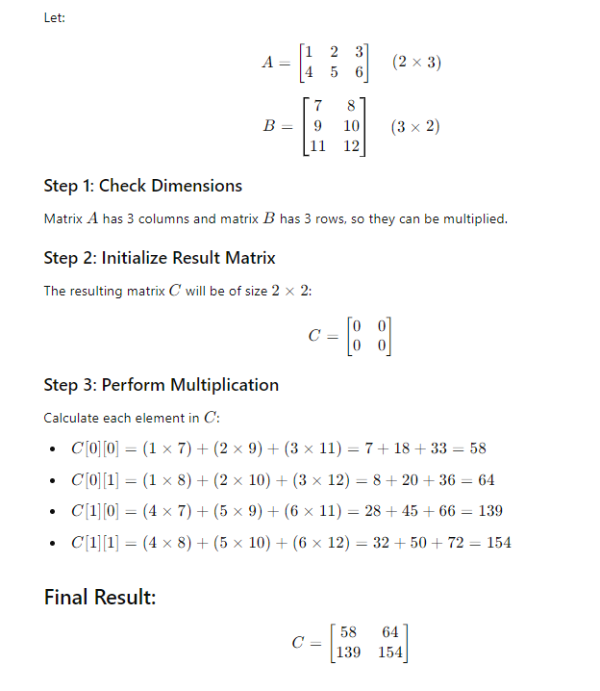

Solution :
#include <stdio.h>
int main()
{
int matA[2][3], matB[3][4], matR[2][4];
int i,j,k;

printf("Enter elements of first matrix of order 2 x 3 \n");
for(i=0;i<2;i++)
{
for(j=0;j<3;j++)
{
scanf("%d",&matA[i][j]);
}
}
printf("Enter elements of second matrix of order 3 x 4 \n");
for(i=0;i<3;i++)
{
for(j=0;j<4;j++)
{
scanf("%d",&matB[i][j]);
}
}
for(i=0;i<2;i++)
{
for(j=0;j<4;j++)
{
matR[i][j]=0;
for(k=0;k<3;k++)
{
matR[i][j]=matR[i][j]+matA[i][k]*matB[k][j];
}
}
}
printf("\nFirst Matrix is \n");
for(i=0;i<2;i++)
{
for(j=0;j<3;j++)
{
printf("%d\t",matA[i][j]);
}
printf("\n");
}
printf("\nSecond Matrix is \n");
for(i=0;i<3;i++)
{
for(j=0;j<4;j++)
{
printf("%d\t",matB[i][j]);
}
printf("\n");
}
printf("\nMatrix multiplication is \n");
for(i=0;i<2;i++)
{
for(j=0;j<4;j++)
{
printf("%d\t",matR[i][j]);
}
printf("\n");
}
return 0;
}

#include <stdio.h>
int main() {
int numbers[5]={1, 2, 3, 4};
printf("%d %d ",numbers, &numbers[0]); //1697645904 1697645904
printf("\n");
return 0;
}
Array as parameter in a function
• When you pass an array to a function, the base address (pointer) of the first element is passed.
• Therefore, any modification inside the function affects the original array.

Prerequisites:

Array Name Represents Its Base Address
When you declare:
int arr[5] = {10, 20, 30, 40, 50};
➡️ The name arr is not a variable — it’s actually a constant pointer that holds the address of the first element (&arr[0]).
So:
arr == &arr[0];

What Happens During Function Call
If you write:
display(arr, 5);
You are not sending the entire array.
Instead, you’re passing only the address of the first element of the array.
That means:
void display(int arr[], int n);
is actually the same as:
void display(int *arr, int n);

No Copying Happens
When you pass an int or float (normal variable), a copy of the value is passed.
But for arrays — only the address (a pointer) is passed, not the entire array.
So any change inside the function affects the original array:
void modify(int arr[]) {
arr[0] = 100; // modifies the original array
}

Expression | Meaning | Type Passed
a | Address of first element | int*
&a | Address of whole array | int (*)[size]
a[0] | First element’s value | int

Example 1
// Online C compiler to run C program online
#include <stdio.h>

void show(int arr[], int n) {
printf("Address inside function: %p\n", arr);
}
int main() {
int a[3] = {1, 2, 3};
printf("Address in main: %p\n", a);
show(a, 3);
}
Output:
Address in main: 0x7ffee4a6d890
Address inside function: 0x7ffee4a6d890
Example 2:
#include <stdio.h>
int main() {
int a[] = {1,2,3,4,5};
int *x = a, i;
for (i=0; i<5; i++){
printf("%d\n", *x);
x++;
}
return 0; }
--------------------------------------------------------
If you want to pass an array to a function, you can use either call by value or call by reference method. In call by value method, the argument to the function should be an initialized array, or an array of fixed size equal to the size of the array to be passed. In call by reference method, the function argument is a pointer to the array.

Pass array with call by value method
In the following code, the main() function has an array of integers. A user−defined function average () is called by passing the array to it. The average() function receives the array, and adds its elements using a for loop. It returns a float value representing the average of numbers in the array.
void display(int arr[], int n);

Example:
Q1. Write a C Program to Print Square of Each Elements In An Array using square function with array and size of array as parameters
#include <stdio.h>
void square(int arr[], int n) {
for (int i = 0; i < n; i++)
arr[i] = arr[i] * arr[i];
}

int main() {
int a[] = {1, 2, 3, 4, 5};
int n = 5;
square(a, n); // passing array to function
for (int i = 0; i < n; i++)
printf("%d ", a[i]);
return 0;
}

Q2. Create an average function with a) array parameter b) array and size of array as parameters
Ans:
- #include <stdio.h>
float average(int arr[5]);
int main(){
int arr[] = {10, 34, 21, 78, 5};
float avg = average(arr);
printf("average: %f", avg);
}
float average(int arr[5]){
int sum=0;
int i;
for (i=0; i<5; i++){
printf("arr[%d]: %d\n", i, arr[i]);
sum+=arr[i];
}
return (float)sum/5;
}

- #include <stdio.h>
float average(int arr[], int length);
int main(){
int arr[] = {10, 34, 21, 78, 5};
int length = sizeof(arr)/sizeof(int);
float avg = average(arr, length);
printf("average: %f", avg);
}
float average(int arr[], int length){
int sum=0;
int i;
for (i=0; i<length; i++){
printf("arr[%d]: %d\n", i, arr[i]);
sum+=arr[i];
}
return (float)sum/length;
}
Questions:
Q1. Write a C Program to Print Square of Each Elements In An Array using square function with array and size of array as parameters
Q2. Create an average function with a) array parameter b) array and size of array as parameters
Pass array with call by reference
To use this approach, we should understand that elements in an array are of similar data type, stored in continuous memory locations, and the array size depends on the data type. Also, the address of the 0th element is the pointer to the array.
void display(int *arr, int n);

Example:
#include <stdio.h>
int max(int *arr, int length);
int main(){
int arr[] = {10, 34, 21, 78, 5};
int length = sizeof(arr)/sizeof(int);
int maxnum = max(arr, length);
printf("max: %d", maxnum);
}
int max(int *arr, int length){
int max=*arr;
int i;
for (i=0; i<length; i++){
printf("arr[%d]: %d\n", i, (*arr));
if ((*arr)>max)
max = (*arr);
arr++;
}
return max;
}
Return an array from a function
A function can be made to return an array by one of following methods –
1. Passing the array as argument and returning the pointer
2. Declaring a static array in a function and returning its pointer
3. Using malloc() function

4. Using Structures
1. Pass array by reference
we declare an uninitialized array in main() and pass it to a function, along with an integer. Inside the function, the array is filled with the square, cube and square root. The function returns the pointer of this array, using which the values are access and printed in main()
Example
#include <stdio.h>
int arrfunction(int x, float *arr) {
arr[0] = x * x; // square
arr[1] = x * x * x; // cube
return 0;
}

int main() {
int x = 100;
float arr[3];
arrfunction(x, arr);
printf("Square of %d: %f\n", x, arr[0]);
printf("Cube of %d: %f\n", x, arr[1]);
return 0;
}
2. Declaring a static array in a function and returning its pointer
we can declare an array inside the called function itself, fill it with the required values, and return its pointer. However, returning a pointer of a local variable is not acceptable, as it points to a variable that no longer exists. Note that a local variable ceases to exist as soon as the scope of the function is over. Hence, we need to use a static array inside the called function (arrfunction) and return its pointer back to main().
Example: // C Program to return an array in C using static arrays
#include <stdio.h>
// Function that returns a pointer to an array
int* getArray() {
static int arr[5] = {10, 20, 30, 40, 50}; // static array (memory persists)
return arr; // return base address of array
}
int main() {
int *ptr;
ptr = getArray(); // receive pointer to array
printf("Elements of returned array:\n");
for (int i = 0; i < 5; i++) {
printf("%d ", ptr[i]);
}
return 0;}

3. Using malloc() function
#include <stdio.h>
#include <stdlib.h>

// Function to create and return an array using dynamic
// memory allocation
int* createArray(int size)
{
// Allocate memory for the array
int* array = (int*)malloc(size * sizeof(int));

// Check if memory allocation was successful
if (array == NULL) {
printf("Memory allocation failed!\n");
exit(1); // Exit the program if allocation fails
}

// Initialize the array with example values
for (int i = 0; i < size; i++) {
array[i] = i * 2;
}

// Return the pointer to the allocated array
return array;
}

int main()
{
// Define the size of the array
int size = 5;
// Call the function to create the array and store the
// returned pointer
int* myArray = createArray(size);

// Print the elements of the array
printf("Array Elements: ");
for (int i = 0; i < size; i++) {

printf("%d ", myArray[i]);
}
printf("\n");

// Free the allocated memory to avoid memory leaks
free(myArray);

return 0;
}

Using Structures
// C Program to return an array in C using Structures
#include <stdio.h>
// Define a structure to hold an array
typedef struct {
int array[5];
} ArrayStruct;

// Function to create and return a structure containing an
// array
ArrayStruct createStructArray()
{
// Declare a variable of type ArrayStruct
ArrayStruct arrStruct;
for (int i = 0; i < 5; i++) {
// Initialize the array
arrStruct.array[i] = i * 2;
}
// Return the structure
return arrStruct;
}

int main()
{
// Call the function to get a structure containing the
// array
ArrayStruct myArrayStruct = createStructArray();
// Print the elements of the array
printf("Array Elements: ");
for (int i = 0; i < 5; i++) {
printf("%d ", myArrayStruct.array[i]);
}
printf("\n");
return 0;
}

